Individual Pathways
Activity 8.2
Investigating forces, energy and motion

- Over a 1-minute period of time, the position of a coach was plotted as she moved along the sideline during a netball game. Her position at 5-second intervals is shown in the table below. Assume that the coach started at the midline of the court.
Time (s) | Position (m)
0 | 0
5 | 3
10 | 6
15 | 6
20 | 6
25 | 7
30 | 8
35 | 9
40 | 10
45 | 10
50 | 8
55 | 4
60 | 0

- Use the values in the table to draw a position-time graph of the coach’s motion over the 1-minute interval.

(b) What distance had the coach walked after 60 seconds? ………………………
- What was the coach’s displacement after 50 seconds? ………………………..
- Calculate her average speed between t = 0 and t = 10 s. Show your working.
.............................................................................................................................................................................................................................................................................................................
- What was her average velocity over the 1-minute time interval? Explain your answer.
.............................................................................................................................................................................................................................................................................................................

- A hamster can cover 9 metres in 38 seconds. What is the speed of the hamster in:
- m/s …………………….
- km/h? ……………………

- The ticker tape below shows the motion of a dynamics cart during an experiment. A ticker timer places 50 dots every second on the tape.

- What interval of time elapses between successive dots? …………………………………
- What period of time elapsed between points A and D? ………………………………
- In which intervals (A to B, B to C, or C to D) did the dynamics trolley:
- decelerate? Explain your answer. ………………………………………………………………………………………………………………………………………………………………………………………………
- remain at a constant speed? Explain your answer. ……………………………………………………………………………............................................................................................................................................................................

- Complete the following table.
Force | Mass | Acceleration
100 N |  | 20 m/s²
 | 300 g | 4 m/s²
1.2 N | 2 kg

- A car is travelling down the highway at 90km/h (25 m/s) when a kangaroo bounces onto the road ahead. The driver takes his foot off the accelerator and brakes hard.
- What deceleration is provided by the car’s brakes if the car takes 4 seconds to come to a complete stop? Show all working.
……………………………………………………………………………………………………………………………………………………………………………………………………
- What force must be exerted by the brakes to stop the car if it has a mass of 1100 kg?
……………………………………………………………………………………………………………………………………………………………………………………………………
- Describe the motion of an unbelted passenger in the car during the deceleration in terms of Newton’s First Law of Motion.
………………………………………………………………………………………………………………………………………………………………………………………………………………………………………………………………………………………………………
- Draw and label arrows on the diagram below to show the forces acting on the car during the deceleration.

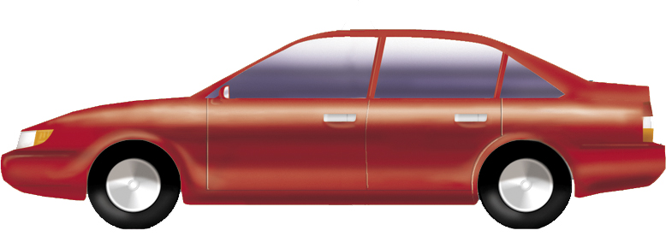

- Are the forces acting on the car balanced or unbalanced while the car decelerates? Explain your answer.
………………………………………………………………………………………………………………………………………………………………………………………………………………………………………………………………………………………………………
- Which two of the forces shown in your diagram are an example of an action-reaction pair?
…………………………………………………………………………………………………

- Explain why the dieting group Weight Watchers should really be called Mass Watchers.
………………………………………………………………………………………………………………………………………………………………………………………………………………………………………………………………………………………………………………………………………

- According to the World Squash Federation guidelines, a standard yellow dot squash ball must fit a strict set of criteria before it is permitted for use in competition. During the bounce test, a squash ball is raised to a height of 120 cm and then dropped onto a smooth concrete floor.
- If the squash ball has a mass of 25 grams, how much work is done to lift the ball from the ground to the test height?
……………………………………………………………………………………………………………………………………………………………………………………………………
- Draw a flow chart describing the energy changes that take place between the time the ball is dropped from the test height and the time it reaches the top of its first bounce.

- WSF regulations state that the bounce height of the squash ball must be at least 28 per cent of its drop height to pass the bounce test. If the squash ball bounces to a height of 35 cm, will it have passed the bounce test? Show all working.
………………………………………………………………………………………………………………………………………………………………………………………………………………………………………………………………………………………………………
- Calculate the gravitational potential energy of the squash ball at the top of its 35 cm bounce height.
……………………………………………………………………………………………………………………………………………………………………………………………………
- If the ball does not bounce back to its drop height, has energy been lost? Explain your answer in terms of the Law of Conservation of Energy.
………………………………………………………………………………………………………………………………………………………………………………………………………………………………………………………………………………………………………

Answers

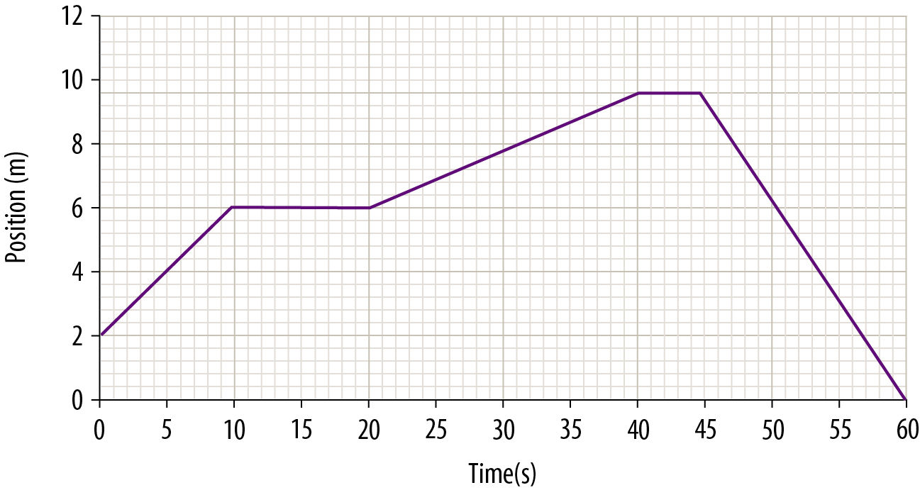
- 20 m
- 8 m
- 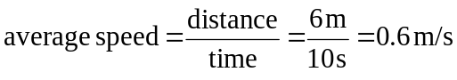
- 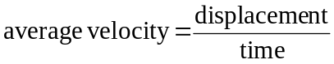
As the coach is back at her starting point at the end of the 1-minute interval, her displacement is 0 at that time. As a result, her average velocity will also be 0.

- 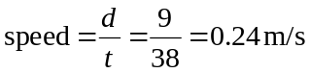
- 0.24 m/s × 3600 s/h × 0.001 km/m = 0.066 km/h

- 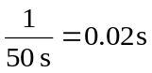
- 14 intervals × 0.02 s/interval = 0.28 s

- C to D: The distance between dots becomes progressively smaller, indicating that the speed of the trolley is decreasing.
- B to C: The distance between the dots remains uniform so the dynamics trolley would have been travelling at a constant speed.

Force | Mass | Acceleration
100 N | 5 kg | 20 m/s²
1.2 N | 300 g | 4 m/s²
1.2 N | 2 kg | 0.6 m/s²

- 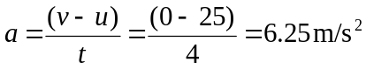
- F = ma = 1100 × (–)6.25 = (–)6875 N
- While the car decelerates, the unrestrained passenger obeys Newton’s first law and continues to move forward with the car’s original speed.

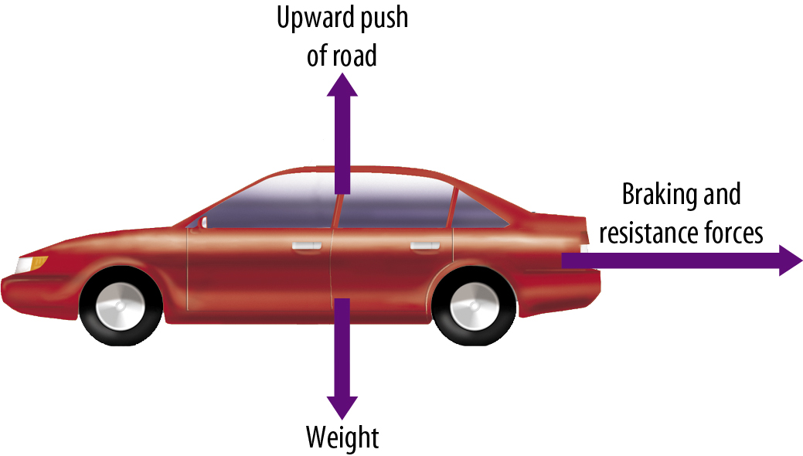
Note that while the car is braking and the accelerator is not being applied, there is no thrust force acting on the car.

- The forces are unbalanced as the car’s motion is changing — it is decelerating under the influence of the braking and resistance forces. If the forces were balanced the car would have continued moving at constant speed.
- Weight and the upward push of the road

- Weight is a measure of the amount of force exerted on an object by gravity. Your weight will be higher or lower depending upon the local gravitational acceleration. Your mass, however, is a measure of the amount of matter that the body contains and remains constant with position. When you lose fat, you are actually removing mass.

- W = Fd = 0.025 kg × 9.8 m/s² × 1.2 m = 0.294 J

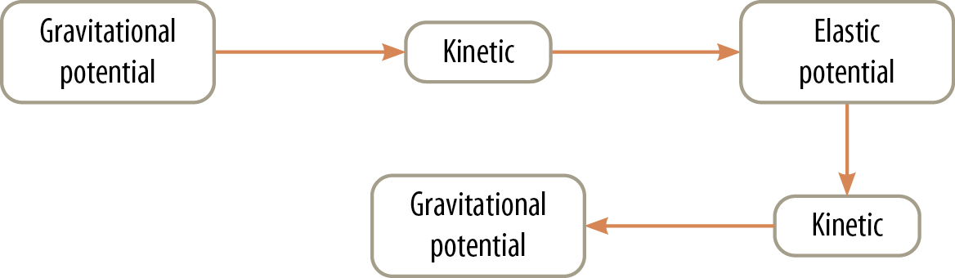

- (35 cm/120 cm) × 100% = 29.2%
Therefore, the ball passes the bounce test.
- GPE = mgh = 0.025 kg × 9.8 m/s² × 0.35 m = 0.087 J
- Energy can be neither created nor destroyed but it can change form into less useful forms, which is what has happened here. Some of the ball’s energy has been converted into less useful forms such as heat and sound, and transferred to the air and the ground. As a result, the ball has less gravitational potential energy at the top of its bounce than it had when it was dropped.

